## Amit. G. Singh

# 25 Dec 1979

+91-9920684985

[kaamitsingh@rediffmail.com](mailto:kaamitsingh@rediffmail.com)

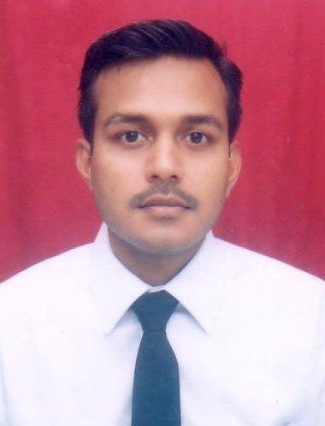

# To decipher the puzzles of business and human behaviour thus arming myself to develop a world-beating workforce, this will add ever-increasing value to organisation and overall environment.

* + - * + **Diligent**
        + **Good Listener**
        + **Vigorously Pursuant**
        + **Energetic**

**Summary**

Over 5 years of experience in HRM across multiple sectors (telecom, pharma, manufacturing, FMCG, consumer goods, real estate, ITES, IT and banking) in HR generalist and consulting role.

|  |  |  |  |
| --- | --- | --- | --- |
| **Period** | **Organization** | **Designation** | **Location** |
| Since August’08 | PricewaterhouseCoopers Pvt. Ltd. | Senior Consultant | Mumbai |
| May’07-July’08 | KPMG | Associate Consultant | UAE |
| September’05-April’07 | Reliance Communications Limited | L-3 (Equivalent to Manager) | Mumbai |
| May’05-September’05 | Videocon International Ltd. | Management Trainee | Aurangabad |

* Lead a team to recommend and implement an **organization structure** along with **manpower** projections based on its overall strategy.
* Design, develop and implement **Balanced Scorecard** including development of Strategy, Corporate Scorecard, Functional Scorecard and Individual Scorecard.
* Develop job description along with performance parameters (KRA’s) to align with the organization structure and actual job content.
* Successfully led team to manage day-to-day HR activities (employee communication, employee grievance etc.)
* Drive a **multi-disciplinary team** toassess the technical and leadership capability for meeting future expansion and cost needs
* Lead a team to identify and develop competency framework for employees across various management levels.
* Conduct **leadership assessment** of management personnel using global tools for **career progression** and **recruitment.**
* Develop **Performance Appraisal System** along with key performance metrics for individuals.
* Execute **Performance Management System** implementation across India (covering more than **20000 employees**)
* Conduct **Job Evaluation** based on global methodology for creating job grades / salary bands.
* Successfully led a recruitment team to recruit more than **750 employees** across multiple levels.
* Conducting **walk-in** drive across India for middle management level staff. (Managing more than 2000 candidates in a day)
* Lead a team for ensuring proper completion of **joining formalities** **/ induction**.
* Develop **HR strategy** and **operational plan** for both a startup and established company.
* Identify and recommend leading HR practices for a new organization setup.
* Develop **HR manual & Employee Handbook** based on prevailing labor laws, leading HR practices and Global policy.
* Driving implementation of training programs by coordinating with various stakeholder departments.
* Act as the **SAP-HR** In-charge – manage day to employee issue, also improve overall employee relations.
* Led a team for Compensation re-structuring of employees across levels.
* Led a team from Finance and HR to migrate payroll system (VB based system to FoxPro-system).
* Lead a team to design and implement tools to measure **employee job satisfaction**.

|  |  |  |
| --- | --- | --- |
| Company Project | | |
| May-July 2004 | **Tata Power** | Mumbai |

**Compensation Management**

* Analysis and interpretation of market survey report on compensation.
* Achieved both internal and external equity within the allocated budget and time period.
* Re-structured the compensation structure (Components).

# Performance Management System

* Study of existing performance management system.

|  |  |  |
| --- | --- | --- |
| **Education** | | |
| June 2003-2005 | **Symbiosis Institute Of Management Studies (SIMS)** | Pune |

* Secured **69.89%** in PGDM (**PM & HR).**

|  |  |  |
| --- | --- | --- |
| Aug 2003-2005 | Symbiosis Law College (MLL & LW) | **Pune** |

* Masters In Labour Law & Labour welfare **(MLL & LW)- 1st Class**

|  |  |  |  |
| --- | --- | --- | --- |
| **Class** | **School/ College** | **Board** | **Marks (%)** |
| B.E (Electronics & Tele-Communication | M.G.M’s College of Engineering and Technology | Mumbai | 55.67 |
| H.S.C (12th) | Fr. Agnel Multipurpose Junior College | Mumbai | 71.33 |
| S.S.C (10th) | Fr. Agnel Multipurpose School | Maharashtra | 80.14 |

|  |
| --- |
| Projects /Presentations /Personal |

* Proficiency in MS-Office.
* **Advanced Training in Excel Skills.**
* **Diploma in Software Management** (Aptech).
* Project on Visual Basic 6.0 and Access.
* Hobbies include **discerning human behaviour** through **Handwriting Analysis** and **Body Language**.
* Underwent a **Personality Development Course** (Indo-American Society).

**Permanent address:**

Plot No. 170, Flat No. 001

Ambe-Ashish Society, Sector-28, Vashi, Navi-Mumbai.

[kaamitsingh@rediffmail.com](mailto:kaamitsingh@rediffmail.com)

[amit.rishabh24@gmail.com](mailto:amit.rishabh24@gmail.com)

**+ (91) - 9920684985**